**Implementation of Minimum Spanning Tree using Prim’s Algorithm**

**INPUT:**

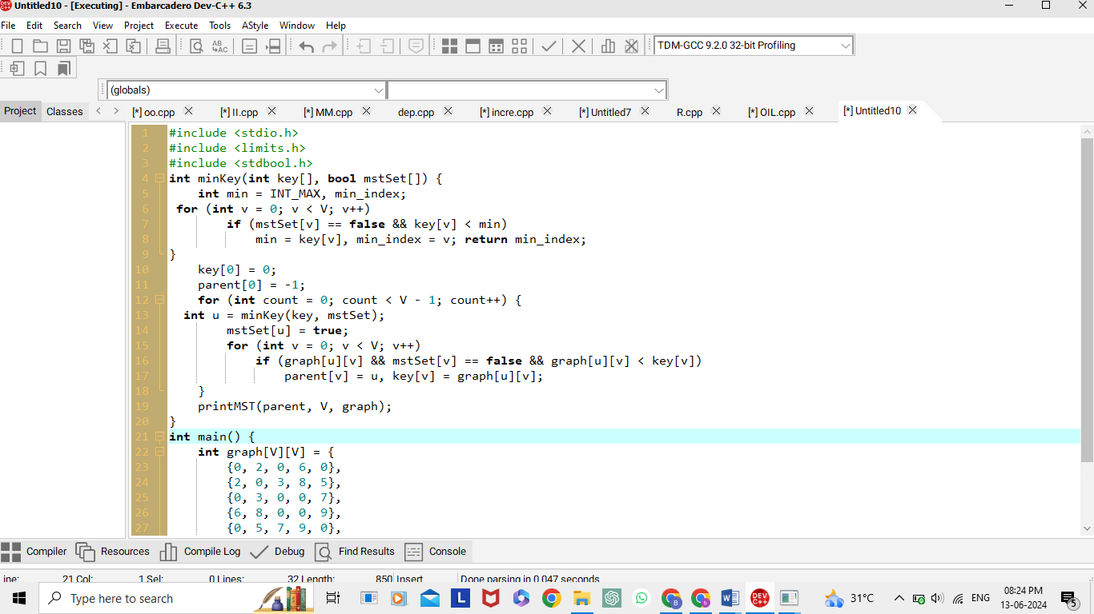

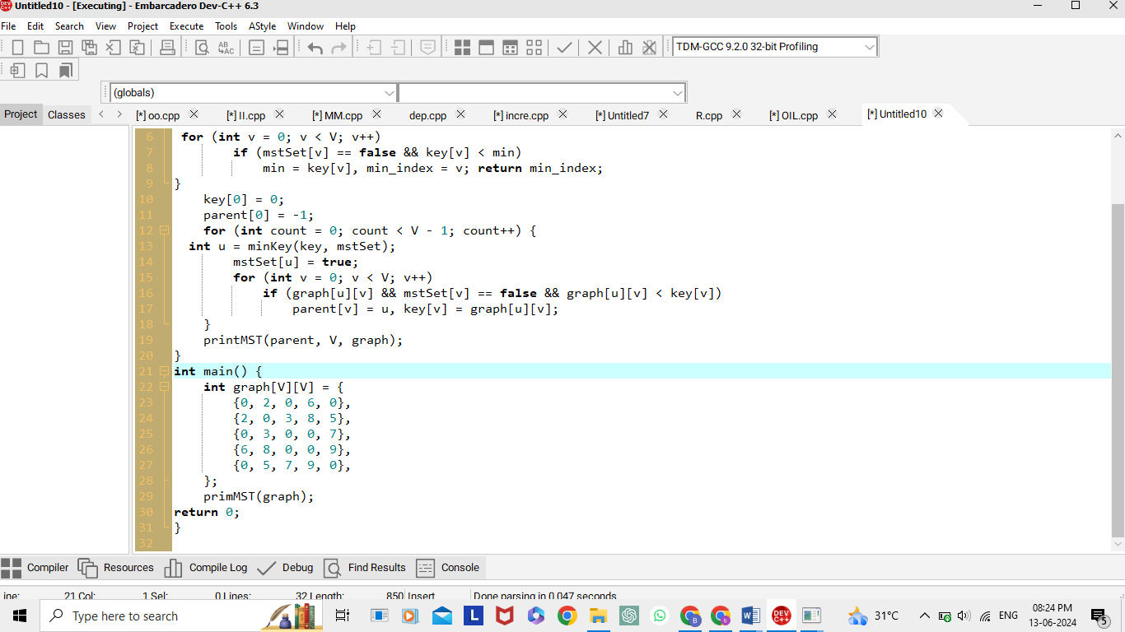

**OUTPUT:**

